**Module-1(SDLC)**

**1.What is Software ?**

*The mission of the Python Software Foundation is to promote, protect, and advance the Python programming language, and to support and facilitate the growth of a diverse and international community of issue calls for proposals regularly. Proposals should be for specific projects with a clear objective, rather than support for ongoing activities.*

**2.What are the types of Applications ?**

*Python is known for its general-purpose nature that makes it applicable in almost every domain of software development. Python makes its presence in every emerging field. It is the fastest-growing programming language and can develop any application.*

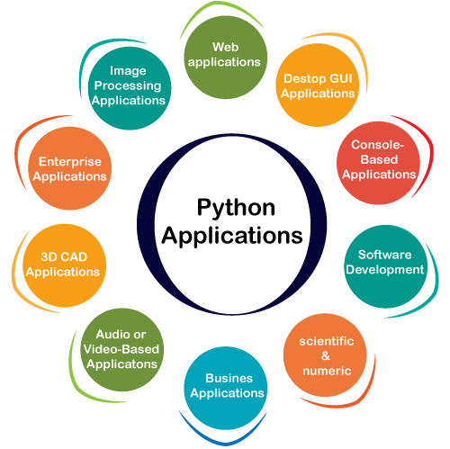

**1) Web Applications**

*We can use Python to develop web applications. It provides libraries to handle internet protocols such as HTML and XML, JSON, Email processing, request, beautifulSoup, Feedparser, etc. One of Python web-framework named Django is used on Instagram. Python provides many useful frameworks, and these are given below:*

* *Django and Pyramid framework(Use for heavy applications)*
* *Flask and Bottle (Micro-framework)*
* *Plone and Django CMS (Advance Content management)*

**2) Desktop GUI Applications**

*The GUI stands for the Graphical User Interface, which provides a smooth interaction to any application. Python provides a Tk GUI library to develop a user interface. Some popular GUI libraries are given below.*

* *Tkinter or Tk*
* *wxWidgetM*
* *Kivy (used for writing multitouch applications )*
* *PyQt or Pyside*

**3) Console-based Application**

*Console-based applications run from the command-line or shell. These applications are computer program which are used commands to execute. This kind of application was more popular in the old generation of computers. Python can develop this kind of application very effectively. It is famous for having REPL, which means the Read-Eval-Print Loop that makes it the most suitable language for the command-line applications.*

*Python provides many free library or module which helps to build the command-line apps. The necessary IO libraries are used to read and write. It helps to parse argument and create console help text out-of-the-box. There are also advance libraries that can develop independent console apps.*

**4) Software Development**

*Python is useful for the software development process. It works as a support language and can be used to build control and management, testing, etc.*

* ***SCons*** *is used to build control.*
* ***Buildbot*** *and Apache* ***Gumps*** *are used for automated continuous compilation and testing.*
* ***Round*** *or* ***Trac*** *for bug tracking and project management.*

**5) Scientific and Numeric**

*This is the era of Artificial intelligence where the machine can perform the task the same as the human. Python language is the most suitable language for Artificial intelligence or machine learning. It consists of many scientific and mathematical libraries, which makes easy to solve complex calculations.*

*Implementing machine learning algorithms require complex mathematical calculation. Python has many libraries for scientific and numeric such as Numpy, Pandas, Scipy, Scikit-learn, etc. If you have some basic knowledge of Python, you need to import libraries on the top of the code. Few popular frameworks of machine libraries are given below.*

* *SciPy*
* *Scikit-learn*
* *NumPy*
* *Pandas*
* *Matplotlib*

**6) Business Applications**

*Business Applications differ from standard applications. E-commerce and ERP are an example of a business application. This kind of application requires extensively, scalability and readability, and Python provides all these features.*

*Oddo is an example of the all-in-one Python-based application which offers a range of business applications. Python provides a* ***Tryton*** *platform which is used to develop the business application.*

**7) Audio or Video-based Applications**

*Python is flexible to perform multiple tasks and can be used to create multimedia applications. Some multimedia applications which are made by using Python are* ***TimPlayer****,* ***cplay****, etc. The few multimedia libraries are given below.*

* *Gstreamer*
* *Pyglet*
* *QT Phonon*

**8) 3D CAD Applications**

*The CAD (Computer-aided design) is used to design engineering related architecture. It is used to develop the 3D representation of a part of a system. Python can create a 3D CAD application by using the following functionalities.*

* *Fandango (Popular )*
* *CAMVOX*
* *HeeksCNC*
* *AnyCAD*
* *RCAM*

**9) Enterprise Applications**

*Python can be used to create applications that can be used within an Enterprise or an Organization. Some real-time applications are OpenERP, Tryton, Picalo, etc.*

**10) Image Processing Application**

*Python contains many libraries that are used to work with the image. The image can be manipulated according to our requirements. Some libraries of image processing are given below.*

* *OpenCV*
* *Pillow*
* *SimpleITK*

**3.What is programming ?**

*Python is an interpreted, interactive, object-oriented programming language. It incorporates modules, exceptions, dynamic typing, very high level dynamic data types, and classes. It supports multiple programming paradigms beyond object-oriented programming, such as procedural and functional programming.*

* ***Free and open-source*** *- You can freely use and distribute Python, even for commercial use.*
* ***Easy to learn*** *- Python has a very simple and elegant syntax. It's much easier to read and write Python programs compared to other languages like C++, Java, C#.*
* ***Portable*** *- You can move Python programs from one platform to another, and run it without any changes.*

**4.What is python ?**

*Python is a general purpose, dynamic, high-level, and interpreted programming language. It supports Object Oriented programming approach to develop applications. It is simple and easy to learn and provides lots of high-level data structures.*

*Python is easy to learn yet powerful and versatile scripting language, which makes it attractive for Application Development.*

*Python's syntax and dynamic typing with its interpreted nature make it an ideal language for scripting and rapid application development.*

*Python supports multiple programming pattern, including object-oriented, imperative, and functional or procedural programming styles.*

*Python is not intended to work in a particular area, such as web programming. That is why it is known as multipurpose programming language because it can be used with web, enterprise, 3D CAD, etc.*

*We don't need to use data types to declare variable because it is dynamically typed so we can write a=10 to assign an integer value in an integer variable.*

*Python makes the development and debugging fast because there is no compilation step included in Python development, and edit-test-debug cycle is very fast.*